Competitive Analysis

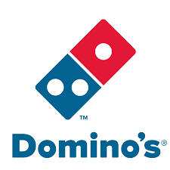  

**Company Info** Name: Domino’s Pizza Name: Mr. Pizza Name: Pizza Lab

HQ: Michigan, USA HQ: Sofia, Bulgaria HQ: Sofia, Bulgaria

Founded: 1960 Founded: 10+ years ago Founded: N/A

**Description** Domino’s Pizza is a multinational Mr. Pizza is a bulgarian Pizza Lab is a bulgarian

pizza delivery company and is the pizza delivery company pizza delivery company

largest pizza seller worldwide in based and operating in operating in the three

terms of sales. the capital city of Sofia. biggest cities in the country.

**Social Media**          

**Product**

 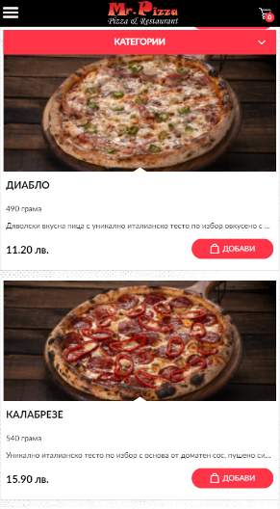 

  

**Strengths &** *Strengths Strengths Strengths*

**Weaknesses** - Easily recognizable - Wide range of products - Very competitive prices

- Has mobile app(s) - Cosy atmospehere - Prices vary according to

- Intuitive interface - Great food quality pizza size, not ingredients

- World-wide famous - Situated mainly in malls

- Rich social media presence - Has mobile app(s)

*Weaknesses Weaknesses Weaknesses*

- Rather expensive - Situated only in one city - Situated mainly in malls

- Does not have mobile app(s) - Relatively small room

- Least social media presence

**Market**

**Breakdown**

*Price Point* $-$$$ $-$$$ $-$$$

*B2B/B2C* B2C B2C B2C

*Retail/Ecommerce* Retail Retail Retail

*Local/Global* Local to each market Local to each market Local to each market

*Products/Services* Products Products Products